*stitching_case1.cpp*

1. Code explanation

1) overall explanation

: this code performs image stitching with feature matching

2) code

#include <opencv2/opencv.hpp>

#include <opencv2/nonfree/nonfree.hpp>

#include <iostream>

#include <vector>

#include <cmath>

#define RATIO_THR 0.4 //ratio threshold

using namespace std;

using namespace cv;

double euclidDistance(Mat& vec1, Mat& vec2);

int nearestNeighbor(Mat& vec, vector<KeyPoint>& keypoints, Mat& descriptors);

void findPairs(vector<KeyPoint>& keypoints1, Mat& descriptors1,

vector<KeyPoint>& keypoints2, Mat& descriptors2, vector<Point2f>& srcPoints, vector<Point2f>& dstPoints, bool crossCheck, bool ratio_threshold);

template <typename T>

Mat cal_affine(vector<Point2f> ptl, vector<Point2f> ptr, int number_of_points);

void blend_stitching(const Mat I1, const Mat I2, Mat& I_f, int diff_x, int diff_y, float alpha);

int main() {

Mat I1 = imread("C:\\Users\\MIN\\Desktop\\권민서\\학교\\2022-1\\오소프\\Lab08\\input1.jpg", CV_LOAD_IMAGE_COLOR);

Mat I2 = imread("C:\\Users\\MIN\\Desktop\\권민서\\학교\\2022-1\\오소프\\Lab08\\input2.jpg", CV_LOAD_IMAGE_COLOR);

Mat I1_gray, I2_gray;

if (!I1.data || !I2.data)

{

std::cout << "Could not open" << std::endl;

return -1;

}

//resize(I1, I1, Size(I1.cols / 2, I1.rows / 2));

//resize(I2, I2, Size(I2.cols / 2, I2.rows / 2));

cvtColor(I1, I1_gray, CV_RGB2GRAY);

cvtColor(I2, I2_gray, CV_RGB2GRAY);

// 1.feature matching

/****************************************************************************/

FeatureDetector* detector = new SiftFeatureDetector(0, 4, 0.04, 10, 1.6);

DescriptorExtractor* extractor = new SiftDescriptorExtractor();

// Compute keypoints and descriptor from the source image in advance

// KeyPoint class instance stores a keypoint found by keypoint detectors such as Harris Corner Detector, SIFT,... etc.

vector<KeyPoint> keypoints1; //keypoints and descriptors in image 1

Mat descriptors1;

detector->detect(I1_gray, keypoints1); //detect keypoints in an image

extractor->compute(I1_gray, keypoints1, descriptors1); //compute descriptors for a set of keypoint in an image

printf("I1 : %d keypoints are found.\n", (int)keypoints1.size());

vector<KeyPoint> keypoints2; //keypoints and descriptors in image2

Mat descriptors2;

detector->detect(I2_gray, keypoints2);

extractor->compute(I2_gray, keypoints2, descriptors2);

printf("I2 : %zd keypoints are found.\n", keypoints2.size());

// Find nearest neighbor pairs (use cross-checking and ratio-based thresholding)

vector<Point2f> srcPoints; //I1

vector<Point2f> dstPoints; //I2

bool crossCheck = true; //cross-checking method 여부

bool ratio_threshold = true; //ratio-based thresholding 여부

findPairs(keypoints2, descriptors2, keypoints1, descriptors1, srcPoints, dstPoints, crossCheck, ratio_threshold);

printf("%zd keypoints are matched.\n", srcPoints.size());

/****************************************************************************/

// 2.affine transform estimation

/****************************************************************************/

I1.convertTo(I1, CV_32FC3, 1.0 / 255);

I2.convertTo(I2, CV_32FC3, 1.0 / 255);

// height(row), width(col) of each image

const float I1_row = I1.rows;

const float I1_col = I1.cols;

const float I2_row = I2.rows;

const float I2_col = I2.cols;

// calculate affine Matrix A12, A21

Mat A12 = cal_affine<float>(dstPoints, srcPoints, (int)dstPoints.size());

Mat A21 = cal_affine<float>(srcPoints, dstPoints, (int)srcPoints.size());

/****************************************************************************/

// 3. Perform image stitching

/****************************************************************************/

// compute corners (p1, p2, p3, p4) using A21

//A21.at<float>(0), ..., A21.at<float>(5)는 affine matrix A21의 a,b,c,d,e,f

Point2f p1(A21.at<float>(0) * 0 + A21.at<float>(1) * 0 + A21.at<float>(2), A21.at<float>(3) * 0 + A21.at<float>(4) * 0 + A21.at<float>(5));

Point2f p2(A21.at<float>(0) * 0 + A21.at<float>(1) * I2_row + A21.at<float>(2), A21.at<float>(3) * 0 + A21.at<float>(4) * I2_row + A21.at<float>(5));

Point2f p3(A21.at<float>(0) * I2_col + A21.at<float>(1) * I2_row + A21.at<float>(2), A21.at<float>(3) * I2_col + A21.at<float>(4) * I2_row + A21.at<float>(5));

Point2f p4(A21.at<float>(0) * I2_col + A21.at<float>(1) * 0 + A21.at<float>(2), A21.at<float>(3) * I2_col + A21.at<float>(4) * 0 + A21.at<float>(5));

// compute boundary for merged image(I_f)

int bound_u = (int)round(min(0.0f, min(p1.y, p4.y)));

int bound_b = (int)round(max(I1_row - 1, max(p2.y, p3.y)));

int bound_l = (int)round(min(0.0f, min(p1.x, p2.x)));

int bound_r = (int)round(max(I1_col - 1, max(p3.x, p4.x)));

// initialize merged image

Mat I_f(bound_b - bound_u + 1, bound_r - bound_l + 1, CV_32FC3, Scalar(0));

// inverse warping with bilinear interplolation using A12

for (int i = bound_u; i <= bound_b; i++) {

for (int j = bound_l; j <= bound_r; j++) {

float x = A12.at<float>(0) * j + A12.at<float>(1) * i + A12.at<float>(2) - bound_l;

float y = A12.at<float>(3) * j + A12.at<float>(4) * i + A12.at<float>(5) - bound_u;

//nearest integer grid

float y1 = floor(y);

float y2 = ceil(y);

float x1 = floor(x);

float x2 = ceil(x);

float mu = y - y1;

float lambda = x - x1;

if (x1 >= 0 && x2 < I2_col && y1 >= 0 && y2 < I2_row)

I_f.at<Vec3f>(i - bound_u, j - bound_l) = lambda * (mu * I2.at<Vec3f>(y2, x2) + (1 - mu) * I2.at<Vec3f>(y1, x2)) +

(1 - lambda) * (mu * I2.at<Vec3f>(y2, x1) + (1 - mu) * I2.at<Vec3f>(y1, x1));

}

}

// image stitching with blend

blend_stitching(I1, I2, I_f, bound_l, bound_u, 0.5);

//show l1,l2, and stitched image

namedWindow("Left Image(input1)");

imshow("Left Image(input1)", I1);

namedWindow("Right Image(input2)");

imshow("Right Image(input2)", I2);

namedWindow("result");

imshow("result", I_f);

//convert l_f into :l_f*alpha + beta

//alpha=255.0 , beta= 0.0(default parameter)

I_f.convertTo(I_f, CV_8UC3, 255.0);

imwrite("result.png", I_f);

waitKey(0);

return 0;

}

//Calculate euclid distance

//vec1, vec2: two matrices. we will calculate euclid distance between them

double euclidDistance(Mat& vec1, Mat& vec2) {

double sum = 0.0;

int dim = vec1.cols;

for (int a = 0; a < dim; a++) {

sum += (vec1.at<float>(0, a) - vec2.at<float>(0, a)) * (vec1.at<float>(0, a) - vec2.at<float>(0, a));

}

return sqrt(sum);

}

// Find the index of nearest neighbor point from keypoints.

// vec: descriptor for fi, keypoints: g1~gm, descriptors: descriptors of g

int nearestNeighbor(Mat& vec, vector<KeyPoint>& keypoints, Mat& descriptors) {

int neighbor = -1;

double minDist = 1e6; //minimum distance between fi and gj

for (int i = 0; i < descriptors.rows; i++) {

Mat v = descriptors.row(i); // each row of descriptor

if (euclidDistance(vec, v) < minDist) {

minDist = euclidDistance(vec, v);

neighbor = i;

}

}

return neighbor;

}

//Find pairs of points with the smallest distace between them and save them in srcPoints, dstPoints

void findPairs(vector<KeyPoint>& keypoints1, Mat& descriptors1,

vector<KeyPoint>& keypoints2, Mat& descriptors2, vector<Point2f>& srcPoints, vector<Point2f>& dstPoints, bool crossCheck, bool ratio_threshold) {

for (int i = 0; i < descriptors1.rows; i++) {

KeyPoint pt1 = keypoints1[i];

Mat desc1 = descriptors1.row(i);

int nn = nearestNeighbor(desc1, keypoints2, descriptors2);

// Refine matching points using ratio_based thresholding

if (ratio_threshold) {

int neighbor = -1;

double secondMinDist = 1e6; //second minimum distance between fi and gj

for (int j = 0; j < descriptors2.rows; j++) {

Mat v = descriptors2.row(j); // each row of descriptor

Mat k1 = descriptors2.row(nn); //row that has minimum distance

if (euclidDistance(desc1, k1) < euclidDistance(desc1, v) < secondMinDist) {

secondMinDist = euclidDistance(desc1, v);

neighbor = j;

}

}

int nn2 = neighbor; //index of second nearest neighbor point

Mat k1 = descriptors2.row(nn); Mat k2 = descriptors2.row(nn2);

if ((double)(euclidDistance(desc1, k1) / euclidDistance(desc1, k2)) >= RATIO_THR) //if ratio < threshold then it is reliable match, otherwise unreliable

continue;

}

// Refine matching points using cross-checking

if (crossCheck) {

Mat desc2 = descriptors2.row(nn);

int l = nearestNeighbor(desc2, keypoints1, descriptors1);

if (i != l) //if unreliable match- 해당 match를 저장하지 않고 다음 pair 로 넘어간다

continue;

}

KeyPoint pt2 = keypoints2[nn];

srcPoints.push_back(pt1.pt);

dstPoints.push_back(pt2.pt);

}

}

//parameter: corresponding pixels, number of points

//return x= (M^T * M)^(−1) * M^T * b -> we can find a,b,c,d,e,f of affine matrix A

template <typename T>

Mat cal_affine(vector<Point2f> ptl, vector<Point2f> ptr, int number_of_points) {

Mat M(2 * number_of_points, 6, CV_32F, Scalar(0));

Mat b(2 * number_of_points, 1, CV_32F);

Mat M_trans, temp, affineM;

// initialize matrix

for (int i = 0; i < number_of_points; i++) {

M.at<T>(2 * i, 0) = ptl[i].x; M.at<T>(2 * i, 1) = ptl[i].y; M.at<T>(2 * i, 2) = 1;

M.at<T>(2 * i + 1, 3) = ptl[i].x; M.at<T>(2 * i + 1, 4) = ptl[i].y; M.at<T>(2 * i + 1, 5) = 1;

b.at<T>(2 * i) = ptr[i].x; b.at<T>(2 * i + 1) = ptr[i].y;

}

// (M^T * M)^(−1) * M^T * b ( * : Matrix multiplication)

transpose(M, M_trans);

invert(M_trans * M, temp);

affineM = temp * M_trans * b;

return affineM;

}

//parameter: I1, I2 merge 할 image 2개

//I_f: merge한 image를 저장

//bound_l, bound_u: boundary for merged image(I_f)

//alpha: I1,I2를 blend할 때 alpha*I1 + (1-alpha)*I2 이용

void blend_stitching(const Mat I1, const Mat I2, Mat& I_f, int bound_l, int bound_u, float alpha) {

int col = I_f.cols;

int row = I_f.rows;

// I2 is already in I_f by inverse warping

for (int i = 0; i < I1.rows; i++) {

for (int j = 0; j < I1.cols; j++) {

bool cond_I2 = I_f.at<Vec3f>(i - bound_u, j - bound_l) != Vec3f(0, 0, 0) ? true : false;

if (cond_I2) //if both l1, l2 are valid

I_f.at<Vec3f>(i - bound_u, j - bound_l) = alpha * I1.at<Vec3f>(i, j) + (1 - alpha) * I_f.at<Vec3f>(i - bound_u, j - bound_l);

else //if only l1 is valid

I_f.at<Vec3f>(i - bound_u, j - bound_l) = I1.at<Vec3f>(i, j);

}

}

}

3) explanation and analysis of the code

1. Feature matching: Compute keypoints and descriptor and perform feature matching using findPairs()
2. Affine transform estimation: use cal_affine()
3. Image stitching: use blend_stitching()

2. Results & analysis

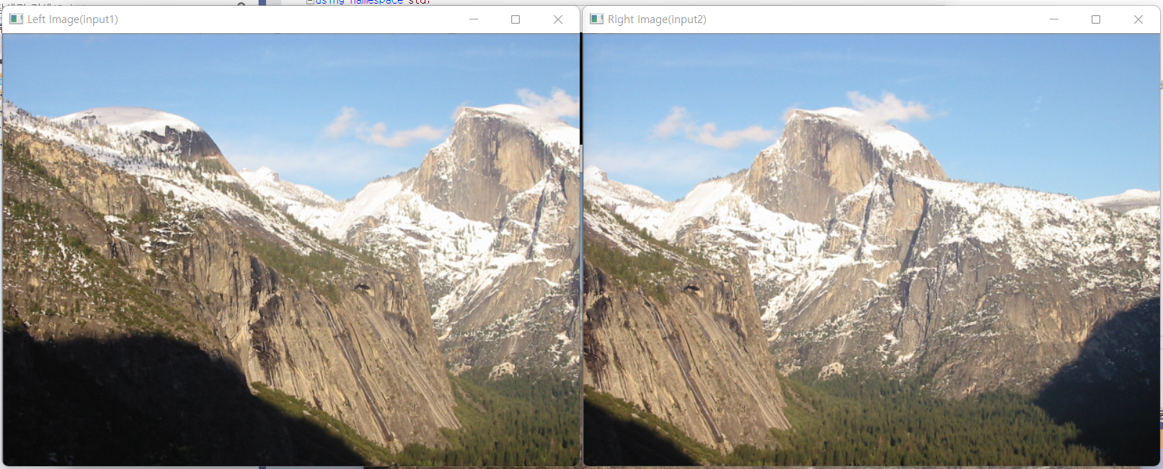

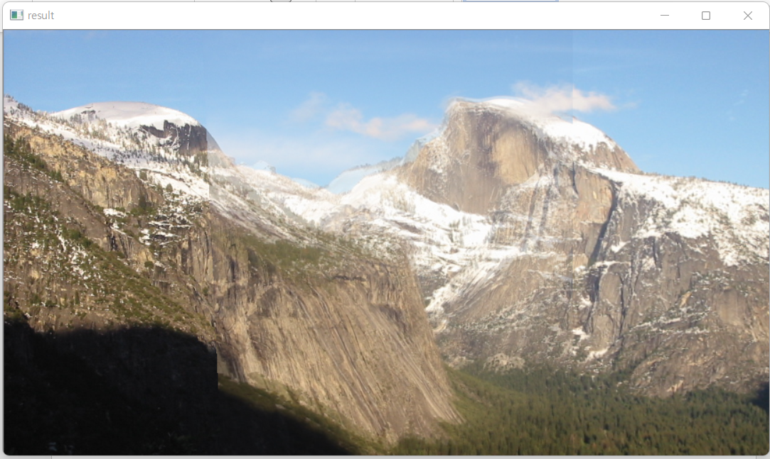

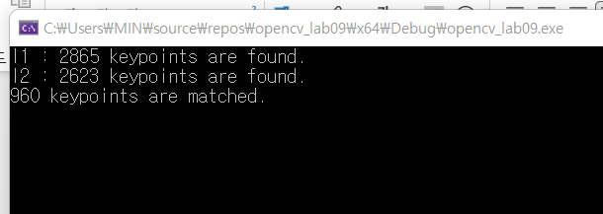

ratio threshold=0.4, alpha=0.5(I1*0.5+I2*0.5 when blend stitching),

*stitching_case2.cpp*

1. Code explanation

1) overall explanation

: his code performs image stitching with feature matching and RANSAC

2) code

#include <opencv2/opencv.hpp>

#include <opencv2/nonfree/nonfree.hpp>

#include <iostream>

#include <vector>

#include <cmath>

#include <random>

#define RATIO_THR 0.4 //ratio threshold

#define INLIER_THR 0.4

using namespace std;

using namespace cv;

double euclidDistance(Mat& vec1, Mat& vec2);

int nearestNeighbor(Mat& vec, vector<KeyPoint>& keypoints, Mat& descriptors);

void findPairs(vector<KeyPoint>& keypoints1, Mat& descriptors1,

vector<KeyPoint>& keypoints2, Mat& descriptors2, vector<Point2f>& srcPoints, vector<Point2f>& dstPoints, bool crossCheck, bool ratio_threshold);

template <typename T>

Mat cal_affine(vector<Point2f> ptl, vector<Point2f> ptr, int number_of_points);

vector<int> get_inliers(vector<Point2f> ptl, vector<Point2f> ptr, Mat& affineM, float threshold, int number_of_points);

void blend_stitching(const Mat I1, const Mat I2, Mat& I_f, int diff_x, int diff_y, float alpha);

int main() {

// 시드값을 얻기 위한 random_device 생성.

random_device rd;

// random_device 를 통해 난수 생성 엔진을 초기화 한다.

mt19937 gen(rd());

Mat I1 = imread("C:\\Users\\MIN\\Desktop\\권민서\\학교\\2022-1\\오소프\\Lab08\\input1.jpg", CV_LOAD_IMAGE_COLOR);

Mat I2 = imread("C:\\Users\\MIN\\Desktop\\권민서\\학교\\2022-1\\오소프\\Lab08\\input2.jpg", CV_LOAD_IMAGE_COLOR);

Mat I1_gray, I2_gray;

if (!I1.data || !I2.data)

{

std::cout << "Could not open" << std::endl;

return -1;

}

//resize(I1, I1, Size(I1.cols / 2, I1.rows / 2));

//resize(I2, I2, Size(I2.cols / 2, I2.rows / 2));

cvtColor(I1, I1_gray, CV_RGB2GRAY);

cvtColor(I2, I2_gray, CV_RGB2GRAY);

// 1.feature matching

/****************************************************************************/

FeatureDetector* detector = new SiftFeatureDetector(0, 4, 0.04, 10, 1.6);

DescriptorExtractor* extractor = new SiftDescriptorExtractor();

// Compute keypoints and descriptor from the source image in advance

// KeyPoint class instance stores a keypoint found by keypoint detectors such as Harris Corner Detector, SIFT,... etc.

vector<KeyPoint> keypoints1; //keypoints and descriptors in image 1

Mat descriptors1;

detector->detect(I1_gray, keypoints1); //detect keypoints in an image

extractor->compute(I1_gray, keypoints1, descriptors1); //compute descriptors for a set of keypoint in an image

printf("I1 : %d keypoints are found.\n", (int)keypoints1.size());

vector<KeyPoint> keypoints2; //keypoints and descriptors in image2

Mat descriptors2;

detector->detect(I2_gray, keypoints2);

extractor->compute(I2_gray, keypoints2, descriptors2);

printf("I2 : %zd keypoints are found.\n", keypoints2.size());

// Find nearest neighbor pairs (use cross-checking and ratio-based thresholding)

vector<Point2f> srcPoints; //I1

vector<Point2f> dstPoints; //I2

bool crossCheck = true; //cross-checking method 여부

bool ratio_threshold = true; //ratio-based thresholding 여부

findPairs(keypoints2, descriptors2, keypoints1, descriptors1, srcPoints, dstPoints, crossCheck, ratio_threshold);

printf("%zd keypoints are matched.\n", srcPoints.size());

/****************************************************************************/

// 2.affine transform estimation

/****************************************************************************/

I1.convertTo(I1, CV_32FC3, 1.0 / 255);

I2.convertTo(I2, CV_32FC3, 1.0 / 255);

// height(row), width(col) of each image

const float I1_row = I1.rows;

const float I1_col = I1.cols;

const float I2_row = I2.rows;

const float I2_col = I2.cols;

// calculate affine Matrix A12 - use RANSAC

int k = 4; // # of randomly sampled points

int S = 15; // # of trials

vector<vector<int>> inliers12(S); vector<vector<int>> inliers21(S);//inlier points의 idx 저장하는 벡터

uniform_int_distribution<int> dis(0, (int)dstPoints.size() - 1); //난수 생성

Mat A12; Mat A21; //best affine transformation

int max_in = 0;//maximum # of inlier pairs

int best_idx=0; // idx of best affine transformation

for (int i = 0;i < S;i++) {

vector<Point2f> random_dst; vector<Point2f> random_src;

for (int j = 0; j < k;j++) { //randomly sample k data

int a = dis(gen);

random_src.push_back(srcPoints[a]);

random_dst.push_back(dstPoints[a]);

}

//estimate affine transformation T

Mat T = cal_affine<float>(random_dst, random_src, (int)random_dst.size());

//compute the inliers satisfying |Tp-p'|^2 < threshold^2

inliers12[i]=get_inliers(dstPoints, srcPoints, T, INLIER_THR, (int)dstPoints.size());

//select the best affine transformation Tb

if (max_in < inliers12[i].size()) {

max_in = inliers12[i].size();

best_idx = i;

}

}

//save Tb's inlier pairs and re-estimate the affine transformation with Tb's inliers

vector<Point2f> inlier_pairs_src; vector<Point2f> inlier_pairs_dst;

for (int i = 0;i < max_in;i++) {

inlier_pairs_src.push_back(srcPoints[inliers12[best_idx][i]]);

inlier_pairs_dst.push_back(dstPoints[inliers12[best_idx][i]]);

}

A12 = cal_affine<float>(inlier_pairs_dst, inlier_pairs_src, max_in);

// calculate affine Matrix A21 - use RANSAC

max_in = 0;//maximum # of inlier pairs

best_idx=0; // idx of best affine transformation

for (int i = 0;i < S;i++) {

vector<Point2f> random_dst; vector<Point2f> random_src;

for (int j = 0; j < k;j++) { //randomly sample k data

int a = dis(gen);

random_src.push_back(srcPoints[a]);

random_dst.push_back(dstPoints[a]);

}

//estimage affine transformation T

Mat T = cal_affine<float>(random_src, random_dst, (int)random_src.size());

//compute the inliers satisfying |Tp-p'|^2 < threshold^2

inliers21[i] = get_inliers(srcPoints, dstPoints, T, INLIER_THR, (int)srcPoints.size());

//select the best affine transformation Tb

if (max_in < inliers21[i].size()) {

max_in = inliers21[i].size();

best_idx = i;

}

}

//save Tb's inlier pairs and re-estimate the affine transformation with Tb's inliers

inlier_pairs_src.empty(); inlier_pairs_dst.empty();

for (int i = 0;i < max_in;i++) {

inlier_pairs_src.push_back(srcPoints[inliers21[best_idx][i]]);

inlier_pairs_dst.push_back(dstPoints[inliers21[best_idx][i]]);

}

A21 = cal_affine<float>(inlier_pairs_src, inlier_pairs_dst, max_in);

/****************************************************************************/

// 3. Perform image stitching

/****************************************************************************/

// compute corners (p1, p2, p3, p4) using A21

//A21.at<float>(0), ..., A21.at<float>(5)는 affine matrix A21의 a,b,c,d,e,f

Point2f p1(A21.at<float>(0) * 0 + A21.at<float>(1) * 0 + A21.at<float>(2), A21.at<float>(3) * 0 + A21.at<float>(4) * 0 + A21.at<float>(5));

Point2f p2(A21.at<float>(0) * 0 + A21.at<float>(1) * I2_row + A21.at<float>(2), A21.at<float>(3) * 0 + A21.at<float>(4) * I2_row + A21.at<float>(5));

Point2f p3(A21.at<float>(0) * I2_col + A21.at<float>(1) * I2_row + A21.at<float>(2), A21.at<float>(3) * I2_col + A21.at<float>(4) * I2_row + A21.at<float>(5));

Point2f p4(A21.at<float>(0) * I2_col + A21.at<float>(1) * 0 + A21.at<float>(2), A21.at<float>(3) * I2_col + A21.at<float>(4) * 0 + A21.at<float>(5));

// compute boundary for merged image(I_f)

int bound_u = (int)round(min(0.0f, min(p1.y, p4.y)));

int bound_b = (int)round(max(I1_row - 1, max(p2.y, p3.y)));

int bound_l = (int)round(min(0.0f, min(p1.x, p2.x)));

int bound_r = (int)round(max(I1_col - 1, max(p3.x, p4.x)));

// initialize merged image

Mat I_f(bound_b - bound_u + 1, bound_r - bound_l + 1, CV_32FC3, Scalar(0));

// inverse warping with bilinear interplolation using A12

for (int i = bound_u; i <= bound_b; i++) {

for (int j = bound_l; j <= bound_r; j++) {

float x = A12.at<float>(0) * j + A12.at<float>(1) * i + A12.at<float>(2) - bound_l;

float y = A12.at<float>(3) * j + A12.at<float>(4) * i + A12.at<float>(5) - bound_u;

//nearest integer grid

float y1 = floor(y);

float y2 = ceil(y);

float x1 = floor(x);

float x2 = ceil(x);

float mu = y - y1;

float lambda = x - x1;

if (x1 >= 0 && x2 < I2_col && y1 >= 0 && y2 < I2_row)

I_f.at<Vec3f>(i - bound_u, j - bound_l) = lambda * (mu * I2.at<Vec3f>(y2, x2) + (1 - mu) * I2.at<Vec3f>(y1, x2)) +

(1 - lambda) * (mu * I2.at<Vec3f>(y2, x1) + (1 - mu) * I2.at<Vec3f>(y1, x1));

}

}

// image stitching with blend

blend_stitching(I1, I2, I_f, bound_l, bound_u, 0.5);

//show l1,l2, and stitched image

namedWindow("Left Image(input1)");

imshow("Left Image(input1)", I1);

namedWindow("Right Image(input2)");

imshow("Right Image(input2)", I2);

namedWindow("result");

imshow("result", I_f);

//convert l_f into :l_f*alpha + beta

//alpha=255.0 , beta= 0.0(default parameter)

I_f.convertTo(I_f, CV_8UC3, 255.0);

imwrite("result.png", I_f);

waitKey(0);

return 0;

}

//Calculate euclid distance

//vec1, vec2: two matrices. we will calculate euclid distance between them

double euclidDistance(Mat& vec1, Mat& vec2) {

double sum = 0.0;

int dim = vec1.cols;

for (int a = 0; a < dim; a++) {

sum += (vec1.at<float>(0, a) - vec2.at<float>(0, a)) * (vec1.at<float>(0, a) - vec2.at<float>(0, a));

}

return sqrt(sum);

}

// Find the index of nearest neighbor point from keypoints.

// vec: descriptor for fi, keypoints: g1~gm, descriptors: descriptors of g

int nearestNeighbor(Mat& vec, vector<KeyPoint>& keypoints, Mat& descriptors) {

int neighbor = -1;

double minDist = 1e6; //minimum distance between fi and gj

for (int i = 0; i < descriptors.rows; i++) {

Mat v = descriptors.row(i); // each row of descriptor

if (euclidDistance(vec, v) < minDist) {

minDist = euclidDistance(vec, v);

neighbor = i;

}

}

return neighbor;

}

//Find pairs of points with the smallest distace between them and save them in srcPoints, dstPoints

void findPairs(vector<KeyPoint>& keypoints1, Mat& descriptors1,

vector<KeyPoint>& keypoints2, Mat& descriptors2, vector<Point2f>& srcPoints, vector<Point2f>& dstPoints, bool crossCheck, bool ratio_threshold) {

for (int i = 0; i < descriptors1.rows; i++) {

KeyPoint pt1 = keypoints1[i];

Mat desc1 = descriptors1.row(i);

int nn = nearestNeighbor(desc1, keypoints2, descriptors2);

// Refine matching points using ratio_based thresholding

if (ratio_threshold) {

int neighbor = -1;

double secondMinDist = 1e6; //second minimum distance between fi and gj

for (int j = 0; j < descriptors2.rows; j++) {

Mat v = descriptors2.row(j); // each row of descriptor

Mat k1 = descriptors2.row(nn); //row that has minimum distance

if (euclidDistance(desc1, k1) < euclidDistance(desc1, v) < secondMinDist) {

secondMinDist = euclidDistance(desc1, v);

neighbor = j;

}

}

int nn2 = neighbor; //index of second nearest neighbor point

Mat k1 = descriptors2.row(nn); Mat k2 = descriptors2.row(nn2);

if ((double)(euclidDistance(desc1, k1) / euclidDistance(desc1, k2)) >= RATIO_THR) //if ratio < threshold then it is reliable match, otherwise unreliable

continue;

}

// Refine matching points using cross-checking

if (crossCheck) {

Mat desc2 = descriptors2.row(nn);

int l = nearestNeighbor(desc2, keypoints1, descriptors1);

if (i != l) //if unreliable match- 해당 match를 저장하지 않고 다음 pair 로 넘어간다

continue;

}

KeyPoint pt2 = keypoints2[nn];

srcPoints.push_back(pt1.pt);

dstPoints.push_back(pt2.pt);

}

}

//parameter: corresponding pixels, number of points

//return x= (M^T * M)^(−1) * M^T * b -> we can find a,b,c,d,e,f of affine matrix A

template <typename T>

Mat cal_affine(vector<Point2f> ptl, vector<Point2f> ptr, int number_of_points) {

Mat M(2 * number_of_points, 6, CV_32F, Scalar(0));

Mat b(2 * number_of_points, 1, CV_32F);

Mat M_trans, temp, affineM;

// initialize matrix

for (int i = 0; i < number_of_points; i++) {

M.at<T>(2 * i, 0) = ptl[i].x; M.at<T>(2 * i, 1) = ptl[i].y; M.at<T>(2 * i, 2) = 1;

M.at<T>(2 * i + 1, 3) = ptl[i].x; M.at<T>(2 * i + 1, 4) = ptl[i].y; M.at<T>(2 * i + 1, 5) = 1;

b.at<T>(2 * i) = ptr[i].x; b.at<T>(2 * i + 1) = ptr[i].y;

}

// (M^T * M)^(−1) * M^T * b ( * : Matrix multiplication)

transpose(M, M_trans);

invert(M_trans * M, temp);

affineM = temp * M_trans * b;

return affineM;

}

//return inlier pairs satisfying |Tp-p'|^2 < threshold^2

//ptl, ptr: data from I1 and I2 / affineM: affine transformation matrix(x from Mx=b) / threshold: inlier threshold / number_of_points: # of matching points in I1, I2

vector<int> get_inliers(vector<Point2f> ptl, vector<Point2f> ptr, Mat& affineM, float threshold, int number_of_points) {

Mat pl(3, 1, CV_32F); //p=(x,y,1)^T

Mat pr(2, 1, CV_32F); //p'=(x',y')^T

Mat temp; //T*p

Mat affineT(2, 3, CV_32F);

vector<int> inlier_idx; //index of inliers satisfying |Tp-p'|^2 < threshold^2

affineT.at<float>(0, 0) = affineM.at<float>(0); affineT.at<float>(0, 1) = affineM.at<float>(1); affineT.at<float>(0, 2) = affineM.at<float>(2);

affineT.at<float>(1, 0) = affineM.at<float>(3); affineT.at<float>(1, 1) = affineM.at<float>(4); affineT.at<float>(1, 2) = affineM.at<float>(5);

for (int i = 0; i < number_of_points; i++) {

pl.at<float>(0, 0) = ptl[i].x; pl.at<float>(1, 0) = ptl[i].y; pl.at<float>(2, 0) = 1;

pr.at<float>(0, 0) = ptr[i].x; pr.at<float>(1, 0) = ptr[i].y;

temp = affineT * pl;

if (euclidDistance(temp, pr) < threshold) {

inlier_idx.push_back(i);

}

}

return inlier_idx;

}

//parameter: I1, I2 merge 할 image 2개

//I_f: merge한 image를 저장

//bound_l, bound_u: boundary for merged image(I_f)

//alpha: I1,I2를 blend할 때 alpha*I1 + (1-alpha)*I2 이용

void blend_stitching(const Mat I1, const Mat I2, Mat& I_f, int bound_l, int bound_u, float alpha) {

int col = I_f.cols;

int row = I_f.rows;

// I2 is already in I_f by inverse warping

for (int i = 0; i < I1.rows; i++) {

for (int j = 0; j < I1.cols; j++) {

bool cond_I2 = I_f.at<Vec3f>(i - bound_u, j - bound_l) != Vec3f(0, 0, 0) ? true : false;

if (cond_I2) //if both l1, l2 are valid

I_f.at<Vec3f>(i - bound_u, j - bound_l) = alpha * I1.at<Vec3f>(i, j) + (1 - alpha) * I_f.at<Vec3f>(i - bound_u, j - bound_l);

else //if only l1 is valid

I_f.at<Vec3f>(i - bound_u, j - bound_l) = I1.at<Vec3f>(i, j);

}

}

}

3) explanation and analysis of the code

1. Feature matching: Compute keypoints and descriptor and perform feature matching using findPairs()
2. Affine transform estimation: use cal_affine() + RANSAC
3. Image stitching: use blend_stitching()

2. Results & analysis

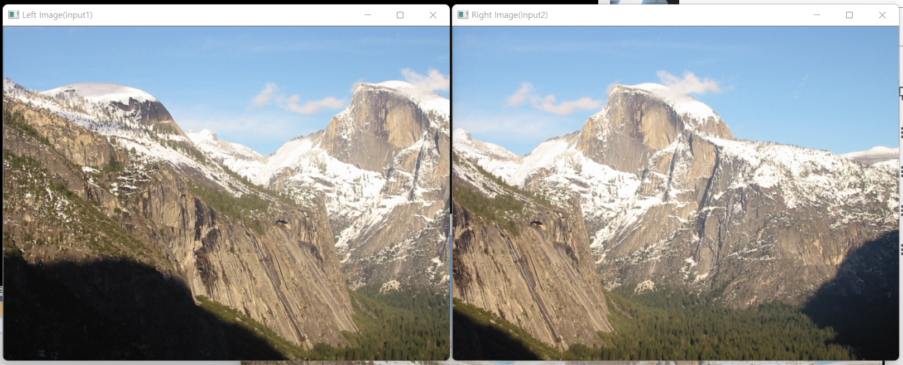

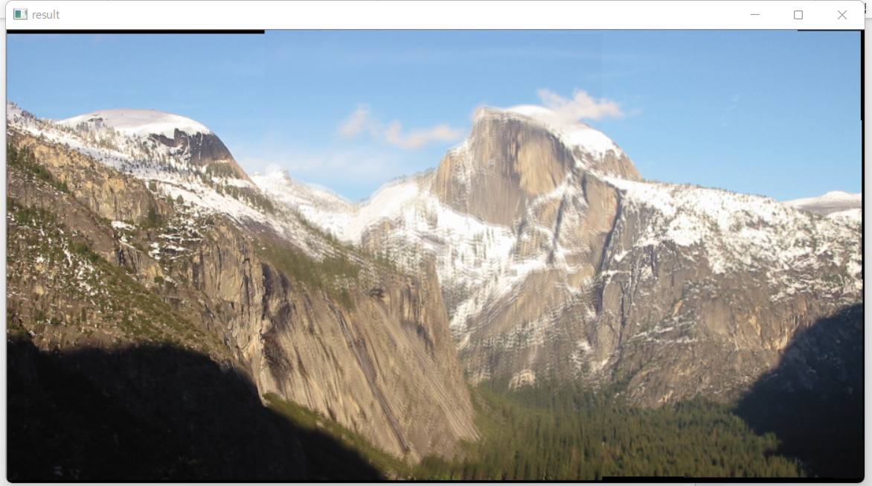

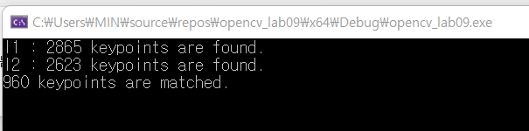

When k=3, S=15, RANSAC threshold=0.4, ratio threshold=0.4, alpha=0.5(I1*0.5+I2*0.5 when blend stitching)

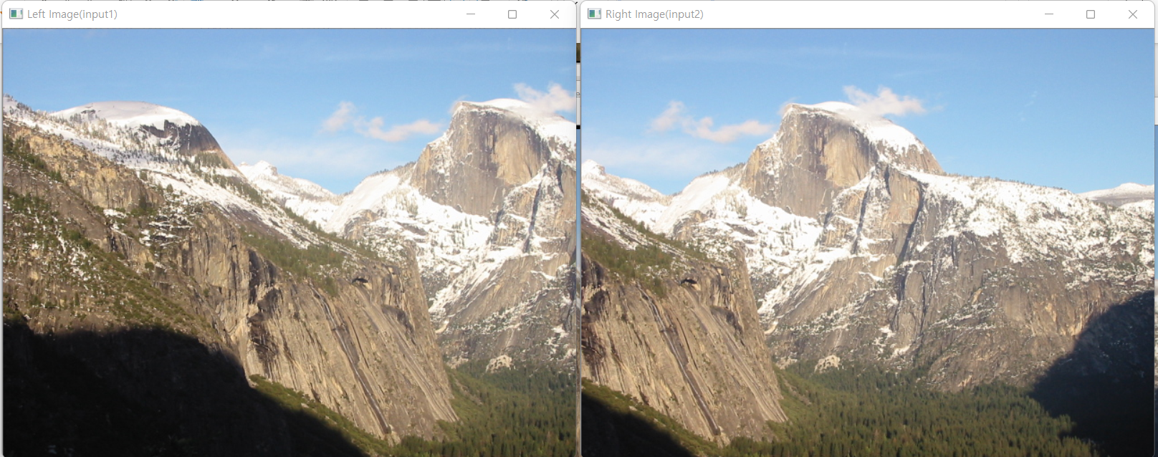

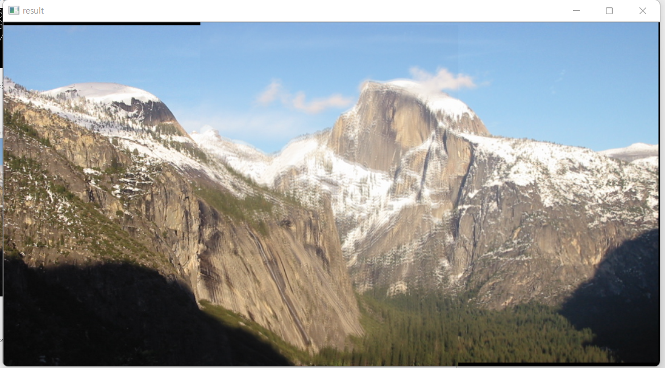

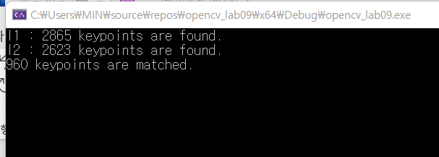

When k=4, S=15, RANSAC threshold=0.4, ratio threshold=0.4, alpha=0.5(I1*0.5+I2*0.5 when blend stitching)

* Hough.cpp*

1. Code explanation

1) overall explanation

: Hough.cpp estimates line segments in the Hough transform by computing the starting and ending points of the line.

2) code

//Standard Hough transform (using 'HoughLines')

#if 1

vector<Vec2f> lines;

HoughLines(dst, lines, 1, CV_PI / 180, 150, 0, 0); // runs the actual detection

for (size_t i = 0; i < lines.size(); i++)

{

//rho, theta: parameters

//x*cos(theta)+y*cos(theta)=r

float rho = lines[i][0];

float theta = lines[i][1];

double a = cos(theta), b = sin(theta);

double x0 = a * rho, y0 = b * rho;

//(0,0)과의 거리가 rho이고 원점에서 수직으로 내렸을 때 각도가 theta인 직선을 그린다

Point pt1(cvRound(x0 + 1000 * (-b)), cvRound(y0 + 1000 * (a)));

Point pt2(cvRound(x0 - 1000 * (-b)), cvRound(y0 - 1000 * (a)));

line(color_dst, pt1, pt2, Scalar(0, 0, 255), 3, 8);

}

//Probabilistic Hough transform (using 'HoughLinesP')

#else

vector<Vec4i> lines;

HoughLinesP(dst, lines, 1, CV_PI / 180, 50, 50, 10); // runs the actual detection

//line: each line is represented by a 4-element vector (x1,y1,x2,y2) , where (x1,y1) and (x2,y2) are the ending points of each detected line segment.

//(x1,y1) and (x2,y2) 를 지나는 직선을 그린다

for (size_t i = 0; i < lines.size(); i++)

{

line(color_dst, Point(lines[i][0], lines[i][1]),

Point(lines[i][2], lines[i][3]), Scalar(0, 0, 255), 3, 8);

}

3) explanation and analysis of the code

Procedure of this code is 1. Run the canny edge detector 2. Run the Hough transform(using HoughLines() or HoughLinesP() ) 3. Draw the line fitting result.

Let’s look into second step.

1. 각 점 (x0,y0)에 대해, (x0, y0)를 지나는 직선은 (rθ,θ) (it is polar coordinate system)로 나타낼 수 있다.

rθ=x0⋅cosθ+y0⋅sinθ

1. 주어진 (x0,y0)를 위 식에 대입하여 (rθ,θ) 에 대한 식을 얻는다. 이는 θ – r plane에서는 sinusoid curve을 나타낸다.
2. 이미지의 모든 points에 대해 동일한 과정을 거친다. If the curves of two different points intersect in the plane θ - r, that means that both points belong to a same line in y-x plane.
3. number of intersections between curves를 찾는다. 만약 the number of intersections >threshold 인 경우, y-x plane에서 직선이 intersection개수만큼의 점을 지나는 것을 의미한다.

2. Results & analysis

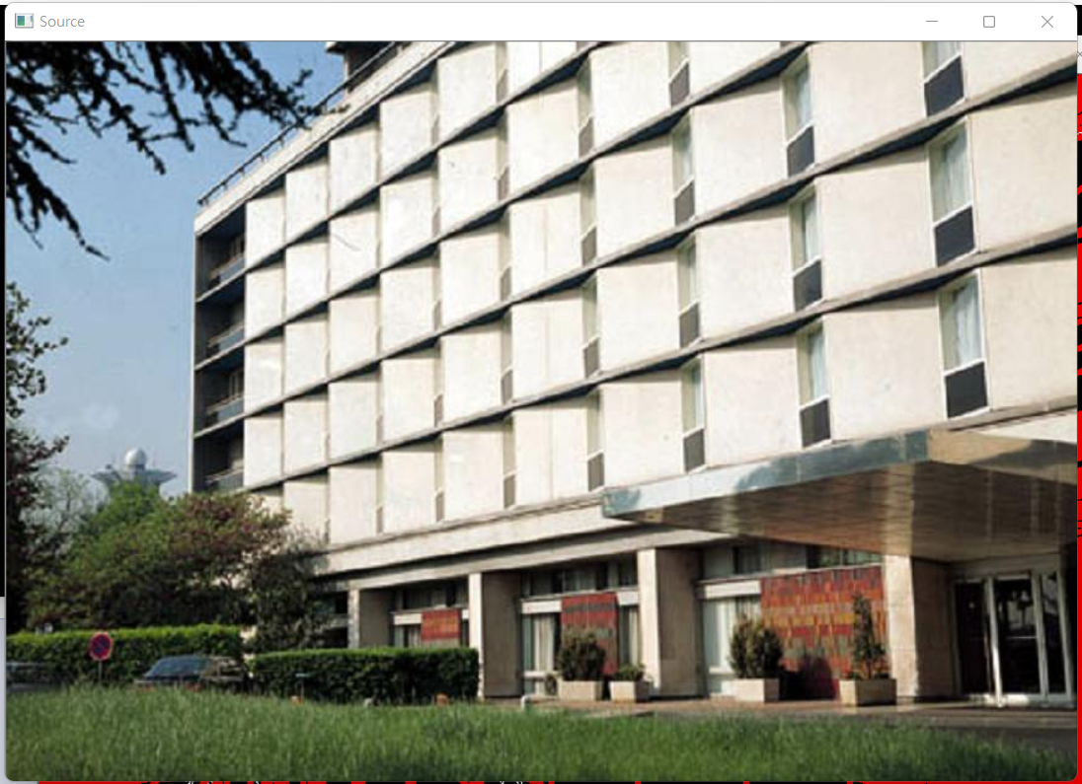

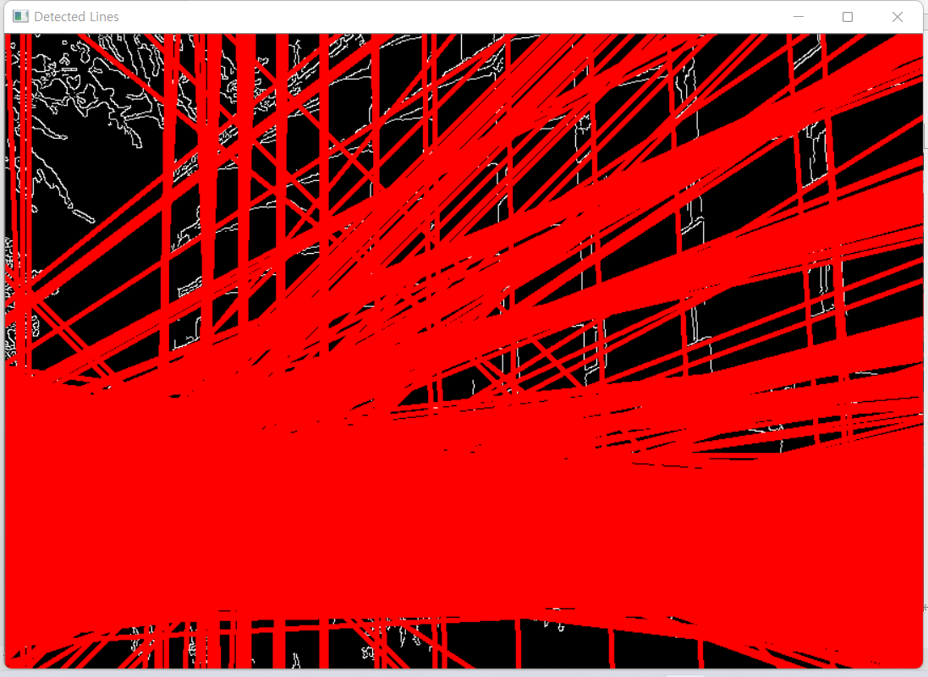

Standard Hough transform (using 'HoughLines')

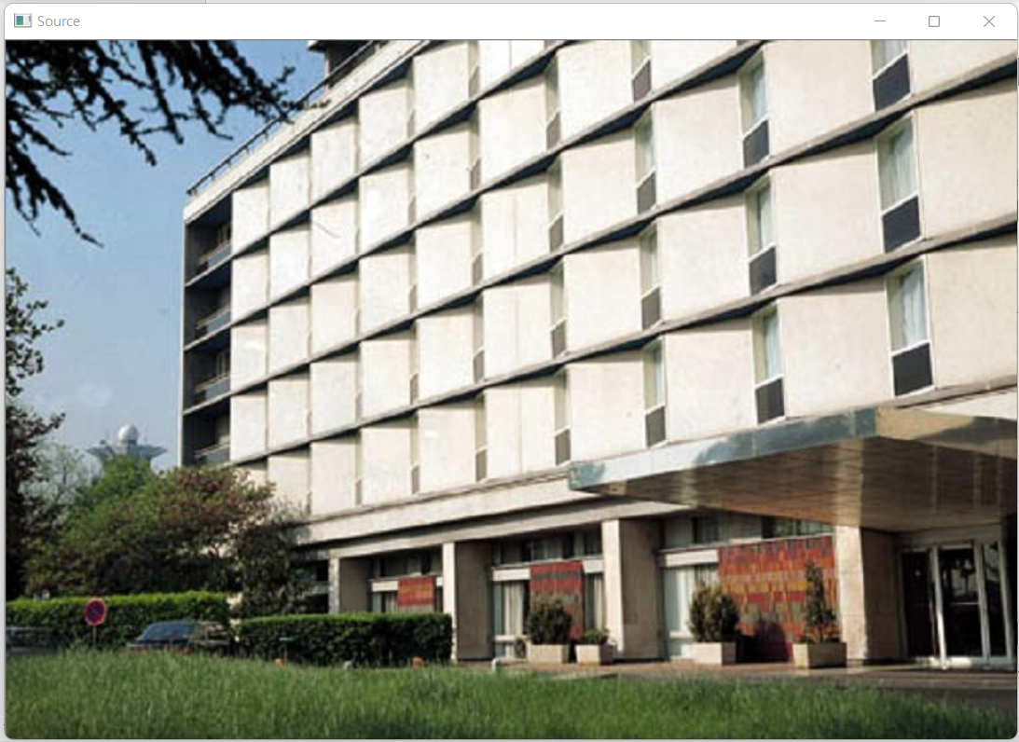

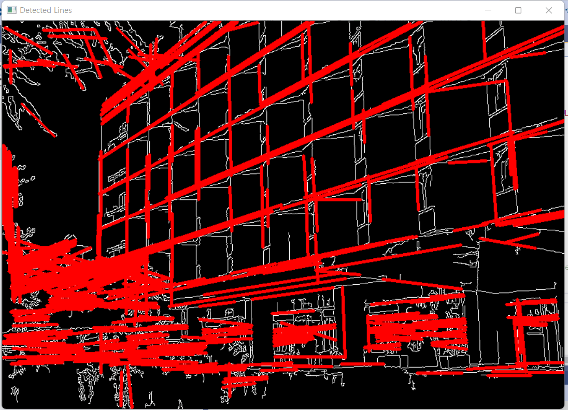

Probabilistic Hough transform (using 'HoughLinesP')